August 11, 2005 URGENT

Ms. Lorraine Olley
Executive Director – Library Administration & Management Association
American Library Association
50 East Huron
Chicago, IL 60611

Dear Lorraine Olley,

RE: NFPA 13 - Report on Proposal (ROP) No. 13-8

Thank you for your call yesterday. Since many of ALA’s members are users of compact shelf storage, also known as compact shelving systems, we want to make you and the ALA membership aware of an impending change to the building code affecting the installation of sprinkler systems over compact shelving systems. If passed, ROP 13-8 would place unjustified economic hardship on the vast majority of compact shelf storage users. We encourage ALA to make its own public comment regarding the impending building code change by September 2nd. The time period for public comment closes on September 2nd.

With this cover letter are the following: a copy of ROP 13-8 (the proposal at issue), Spacesaver Corporation’s Public Comment Form (FOR EXAMPLE ONLY), a Public Comment Form (BLANK ONE FOR YOUR USE) and a template of its corresponding Problem and Substantiation Statement (TEMPLATE FOR YOUR USE).

As you will see from the attached template Problem and Substantiation, there are several problems with the Technical Committee’s proposal. If passed, the new sprinkler criteria in proposal 13-8 would place unjustified economic hardship on the vast majority of compact shelf storage users. We urge you to make public comment by September 2nd recommending that the Technical Committee delete the text in this proposal and hold any new text regarding compact shelf storage for further study.

Thank you in advance for your consideration. Please contact me with questions.

Sincerely,
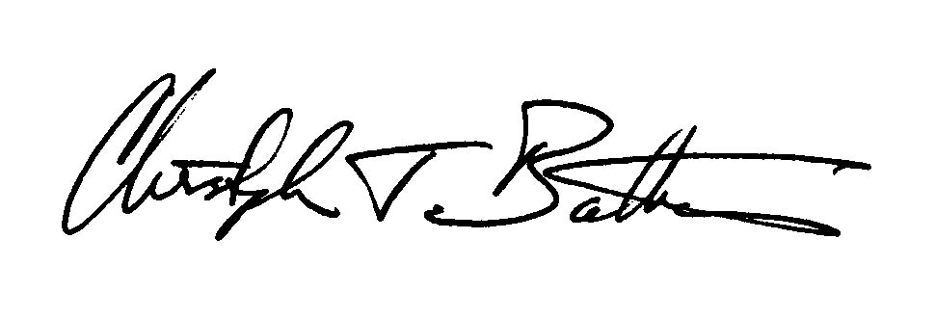
Christopher T. Batterman, Director of Market Development
Spacesaver Corporation
Tel 920.563.0510, Cell 920.723.1355
Email cbatterman@spacesaver.com input.doc

Attachments: ROP 13-8
Spacesaver Corporation’s Public Comment Form (FOR EXAMPLE ONLY)
Public Comment Form (BLANK ONE FOR YOUR USE)
Problem and Substantiation Statement (TEMPLATE FOR YOUR USE)

Cc: Paul Olsen, President, Spacesaver Corporation

