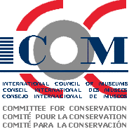

N E W S L E T T E R

WORKING GROUP : TEXTILES
GROUPE DE TRAVAIL : TEXTILES

GRUPO DE TRABAJO : TEXTILES

ISSN 1027-1589 No. 23 November 2005

CONTENTS

FROM THE CO-ORDINATOR 1

REDUCING THE STRAIN 4

SALVAGE OPERATION IN SARNEN
SWITZERLAND 6

CONFERENCE REPORTS:
Recovering the Past, NATCC 2005, Mexico City 9
The Preservation of Religious Textiles 14

CALENDAR OF MEETINGS & COURSES:
Textile Conservation in Brazil 16
Colour & Time 16
Textiles and Text 17

NOTICES:
Issues is the Conservation of Textiles 19
Metal Threads – Call for Volunteer 19
Textile Conservation at the U of Alberta 19
The Eu-ARTECH Project 20
Textiles Off-campus Programs (TOP) 21

BOOKS:
ICOM 14th Triennial Meeting Preprints 21
Unravelling Textiles 22

OBITUARY: KATHRYN O. SCOTT 22

NEWSLETTER SUBMISSIONS 23

FROM YOUR CO-ORDINATOR

Holiday greetings to everyone!
Textile conservators enjoyed a wonderful September in the Netherlands — with a symposium on Religious Textiles hosted by

the Textielcommissie Nederland (Textileommittee of the Netherlands) and
four excellent ICOM –CC Textile Working Group sessions. There were informative presentations and posters, good discussions, and great camaraderie. Some members were able to avail themselves of the kind offer by De Wit Manufactures to visit the De Wit tapestry conservation studios. We are happy to report that the Textielcommissie Nederland will be publishing the symposium next year, that James and James offers the two volumes of the ICOM-CC Triennial meeting for your library and that information about De Wit can be found at http://www.dewit.be .

We are now embarking on the next Triennial program, during the period 2005-2008. With your help, we would like to establish a working program that everyone can participate in—with the ICOM-CC Textiles Working Group Newsletter, with papers or posters at an Interim Meeting, with communications about other activities and short research projects in the Newsletter, and also at the next, 15th Triennial Meeting. Please review the draft of this program and let me know your comments!

The next ICOM-CC Triennial Meeting will be held in Delhi, India September 22-26, 2008. We would like to incorporate a theme that will reflect the richness of the cultural patrimony of India into our program. Please send me your suggestions and ideas!
We are hoping to hold an Interim Meeting with the Leather and Wood/Lacquer/Coatings Working Groups in Eastern Europe in September 2007. The theme of this meeting will be
“Upholstery +”! That is, we shall look to focus our attention on presentations about upholstery issues but we shall also be happy to see new ideas, new methods, and new techniques for textile conservation issues at this time. Please plan to attend—and to bring us your latest success in poster or presentation form! We will be announcing a call for papers and poster abstracts and the precise location in the next TWGNewsletter (2006).

We are also fortunate to have Christine Mueller-Radloff (at c0416m@aol.com ) volunteer to be the Assistant Coordinator in charge of making a Textile Working Group Directory. This Directory will help us all locate members around the world. Her efforts will also help many of us to overcome the restrictions imposed by the secretariat on the website (see this issue (“Announcement from the Board of Directors of ICOM-CC”).

With best wishes for a wonderful 2006 to all,

Mary W. Ballard, Coordinator Textiles Working Group
Elsje Janssen, Assistant Coordinator Textiles Working Group

Programme 2005-2008 Textiles Working Group

1. The next Triennial Meeting of the ICOM-Conservation Committee is scheduled for Delhi, India in the fall of 2008. For this meeting, a theme will be developed soon to evoke an aspect of the cultural patrimony of India and its parallel forms in other countries. However, we should keep in mind that the general assembly of ICOM has already chosen the theme “Museums—the foundation of understanding” to focus on how museums inform visitors and also act as the repository for the history of a region, period, or culture. Textile conservators often see interesting examples of the object as a documentation of past life, so this ICOM theme seems natural to us!

2. The membership of the working group needs to be expanded to include more colleagues active in textile conservation. We are grateful to training programs that promote ICOM-CC to their students and urge them to participate, to independent conservators that join, and to museums that support their conservators in attending the meetings.

3. Two excellent Assistant coordinators have come forward to help organize the activities of the Working Group. Elsje Janssen, co-ordinator of collection management and head of conservation for the city of Antwerp, assists with the program activities of the Working Group. Now Christine Mueller-Radloff, textile conservator at SES-Museum für Völkerkunde, Leipzig, has joined us to help organize a directory of members. We are concerned that we reach colleagues everywhere adequately and effectively.

4. The Textile Conservation Working Group Newsletter is being published twice a year under the co-editorship of Jan Vuori (Canadian Conservation Institute), Pia Christensson (Helsinborgs Museer, Sweden), and Tracey Wedge (private conservator, New Zealand). We would like to have summaries of interesting projects, ongoing problems, and upcoming studies in your area, city, region, and nation. This is an opportunity to report in a few paragraphs on a major development to colleagues around the world—in English, French, or Spanish.

5. An interim meeting is in the planning stages for the spring of 2007. We hope to join the Leather Working group and the Wood/Lacquer/Coatings for a meeting in Poland. The focus of the interim meeting will be on Upholstery (but tangential issues are fine too).

Announcement from the Board of Directors of ICOM-CC

In the past and till today, membership lists of individual working groups were composed of ICOM members, who had indicated ICOM-CC as the international committee they were interested in, and of non-members. To this will be added now also 'Friends' and 'Student-Friends'. Important actions that will further change working group membership are listed below.

1. from January 1st 2005 onwards, only working group members, whatever their status, will have access to all levels of information of the ICOM-CC website

2. from October 1st 2005 onwards, only working group members who are either members of ICOM or
(Student-)Friends of ICOM-CC, will have access to all levels of information of the ICOM-CC website

3. from January 1st 2006 onwards, all working group members who are
neither a member of ICOM nor a
(Student-)Friend of ICOM-CC must be removed from the working group list

This schedule of events implies that you have to send the complete list of your working group membership, including and indicating members of ICOM,
(Student-)Friends of ICOM-CC and others, to our secretariat at
secretariat@icom-cc.org giving for each member surname, name, registration
number at ICOM or as (Student-)Friend, and email address. This data will be
introduced at the web and at first login, a password will have to be generated.

Textile Working Group Directory

The secretariat of ICOM-CC wants to keep track of our membership because, beginning this month, they will be restricting access to sections of the www.icom-cc.org website to ICOM-CC members. Many of the working group coordinators and assistants think these restrictions will be detrimental to the organization. Your textile working group coordinators share this viewpoint. However, we will provide the Directory to the secretariat in order to minimize the effects on our members. If you have already sent your ICOM registration number and email address to the co-ordinator or you have attended the ICOM-CC 14th Triennial Meeting at the Hague, you are probably registered with the secretariat. When you login at the icom-cc website, you need only use the phrase icom-cc as your password. Please try this. If you have problems please email Mary Ballard ballardm@si.edu this information:

YOUR NAME/Nom/Nombre:
ICOM-CC Number:
EMAIL:
ADDRESS/Adresse/ Dirección:
Institutional Affiliation (if any)/Institut ou organization (sidisponible)/Afiliación institucional (si tiene):

Thank you for your patience in this matter!

A Holiday professional gift for yourself!

Holiday greetings to everyone! I would urge everyone not yet a member to consider joining the International Council of Museums--Conservation Committee! The Conservation Committee meets every three years (next time autumn, 2008 in New Delhi, India) and provides textile conservators an opportunity to meet others in the field from different countries, with the same types of conservation issues. In addition, there is oftentimes an interim meeting: in the past, in Athens, Amsterdam, and in Sicily. These are also very worthwhile conferences.

There is an ICOM-Conservation Committee Newsletter and also this Textile Conservation Group newsletter. As you can see, the textile newsletter provides information about issues and textiles conservation research from different nations. The official languages are English, French and Spanish. In addition, the ICOM membership card provides FREE ENTRY TO MUSEUMS all over the world--from the Museum of Modern Art in New York to the Louvre in Paris to Uffizi in Florence.

To join the ICOM-CC you apply in your home country. Each country has its own application form and method. In the United States, conservators join via the AAM ($65+$20fee annually (http://www.aam-us.org/museumresources/icom/index.cfm). In Canada, it costs about C$100, in the United Kingdom 42 pounds; in Sweden 515 kr--about the same. There are about 350 members of the ICOM-CC Textile Group! Please join us! For further information about ICOM in your country, please go to www.icom.org and click for membership information.

For more information about the Conservation Committee, the website is http://www.icom-cc.org . Students and those who prefer a lower free can simply become a “Friend of ICOM-CC.” This is a limited membership that does not provide the ICOM-CC museum card; there are no “voting privileges” but you will receive access to the login only parts of the ICOM-CC website. This membership may be helpful to those living in a country with an unresponsive national committee. Friends of ICOM-CC have membership fees of € 40 or € 20 annually; Student-friends have annual fees of €25 or €10. The difference levels refer to the relative national income levels. Please consult http://www.icom-cc.org/ for further information. The ICOM year is January 1 through December 31. Join now to maximize your benefits!

The following article by Katharine Barker was originally published in the September 2002 issue of Conservation News, a publication of the United Kingdom Institute for Conservation (UKIC) which is now part of the Institute for Conservation (ICON)
www.instituteofconservation.org.uk

Reducing the Strain
Is it worth displaying a large fragile textile at a slight angle?

Textile conservators, when asked to display large and fragile textiles on upright boards or walls, often negotiate the compromise of tilting the board back by a few degrees to reduce some of the strain. Perhaps this comes from knowing what a relief it is to lean against the wall for a few minutes at the end of a day standing up! Surely, an inner sense suggests, a tapestry, which has “stood up” for several hundred years, will appreciate leaning in the forthcoming exhibition. Recently, while advising a client with a set of large tapestries to display, I decided to work out mathematically just how appreciative a tapestry ought to be (or otherwise) for a proposed small tilt in its backdrop. I shall explain my findings in two ways, first mathematically and secondly by drawing on general observations.
When a tapestry is displayed on a board at angle to a wall (see fig. 1 below) the weight, ie. the downward force due to gravity, is split in two:

• Force 1 acts into the board. This force is opposed by an equal force, which a conservator would call the support given by the board . If the two weren’t equal, either the tapestry would push its way through the board, or fly off across the room.

• Force 2 acts down the length of the tapestry and is opposed by effects of the Velcro fixings at the top. It is what we call the strain on the tapestry.

The size of Force 2, the strain on the tapestry can be calculated by trigonometry:

Force 2 = the cosine of angle a x the mass of the tapestry.

The mass of the tapestry remains constant, whatever the angle, therefore Force 2 is proportional to cosine a.

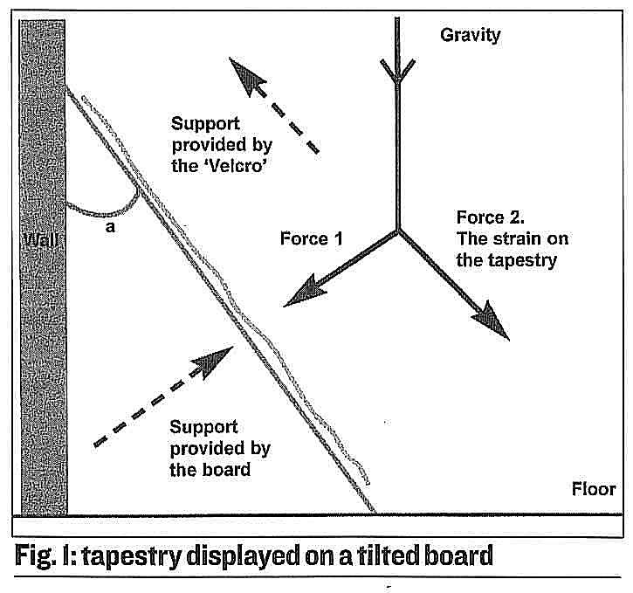

The magnitude of Force 2, or downward strain through a tapestry, can be expressed as a percentage of its weight for a given angle. Results for various angles are shown in Table 1. Obviously, when the angle is zero, the strain down the length is 100% and when it is 90°, ie. horizontal, there is no strain at all. The surprising result is that for 25°, probably a greater angle than would be considered for a large item, the strain is still 90%. Halfway down, 45°, it is just over 70% and to get a 50% reduction the tapestry must be at 60°. Clearly then, a tilt of a few degrees off the vertical is just not worth the trouble on conservation grounds. Conversely, a textile that needs to be shown horizontally can be raised for ease of viewing, be several degrees, with no ill effect.

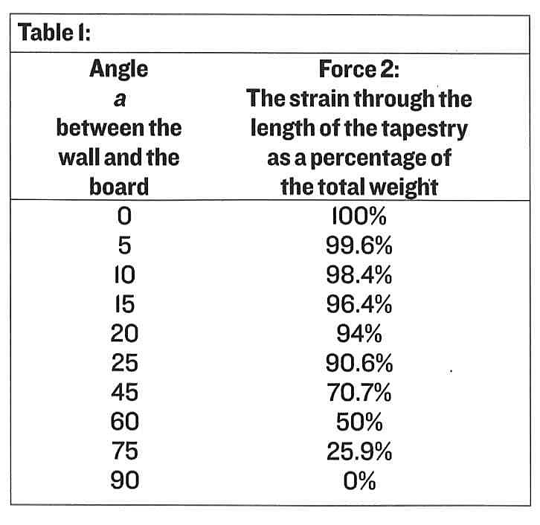

Let us now consider the same effects, but from an everyday observational point of view. Imagine you are in a gallery, holding an enormous glass panel for a display case. It is resting on the floor, on its long edge. All its weight is pressing through itself, making an indentation in the gallery carpet. You can keep it in position with fingertips alone, with no effort, even when it is a few degrees off vertical. However, when your colleagues fail to return, you decide to try and lower the piece of glass to the floor. Assuming that the pile of the carpet is deep enough to prevent the bottom edge from slipping, imagine the increased effort and weight that you will carry as your “top” edge gets closer to the floor. It will not get seriously difficult until you are a long way down and, at that final moment, only the deep pile of the carpet will save your fingers! You are acting in the same role as the supporting backboard in the mathematical version, ie. taking a greater proportion of the strain as the angle gets bigger.

Returning to the tapestry or large textile, conservators will sometimes consider using a slightly rough fabric to cover a display board to provide friction and give overall support to an object. We all know that silk against silk is without friction, whereas two pile or rougher fabrics will not slide against each other so easily. This tendency of two fabrics to stick or slip is called the co-efficient of static friction. The most pull or weight that which a pair of fabrics will carry due to friction is calculated by:

The maximum weight or pull = co-efficient of static friction x the force into/out of the mounting board (ie. Force 1, above.)

For useful, near upright angles, Force 1, we know from the calculations above. Is very small. Therefore, unless the “stickiness” or friction between the mounting board and the back of the textile is high, the downward strain through the textile will be relatively unaffected. If you can slide two fabrics over each other, they will not carry much strain in a vertical situation.

Finally, returning to leaning against walls, why is it sometimes such a relief? Probably because the changes in stance is affecting which muscles are being used and how, rather than the wall taking the weight off your feet!

Katharine Barker

Salvage operation in Sarnen, Switzerland

While the whole world turned their attention to hurricane Kathrina slowly approaching the US coast, Switzerland, southern Germany and Austria suffered inundations of a unusual scale. Heavy rainfalls throughout summer had soaked the ground and caused the level of rivers and lakes to rise to alarming levels. On August 21st and 22nd even stronger rain poured down: between 100 and 130 mm/24h of water were measured in an mountainous area covering more than a third of Switzerland, causing inundations and landslides. Switzerland is rather well prepared for smaller scale and localized disasters, including inundations. However, the large scale of the events in late August overwhelmed everybody. Supplies ran out, military and civil protection services (Switzerland does not have a professional military, but a militia system) were called in for almost uninterrupted several weeks of tough rescue service.

As far as museums are concerned, only two collections suffered extensive water damage: The Museum of Transportation in Lucerne, and an outside storage premise of the Historic Museum Berne (storage facilities located near Thun). In addition the important collection of the women's cloister “St. Andreas” in Sarnen, counting over 3000 objects of applied art dating from 13th to 19th c. and including a very important textile and manuscript collection, was heavily affected. It was to this site that I, as a Textile Conservator, and a colleague (Paper Conservator) were called by the cultural protection department of the Swiss Civil Protection Agency. A Paintings/Sculpture Conservator, working on a different site, was in constant contact with us and later on took care of painted and gilded wooden and gypsum sculpture.

The cloister, a “seclusion” normally closed to the public, only recently had relocated the collection to an underground, so-called “cultural property protection room”. Previously the treasures had been spread throughout the cloister's buildings, mainly in the attics. Fire police and the Cultural Property Protection Agency, worried about the risk of fires and the difficult if not impossible work to rescue such a widely spread collection, had pushed (and paid for) this protection room which was installed in a former shelter. The room had been refurbished with a second concrete shell (because the existing concrete dated from the early 50's). Half of the room was turned into a storage area with mobile shelves. The other half was equipped with vitrines and provided an “exhibition area”, which was accessible only to very few and selected persons. This newly furbished room was inaugurated in 2003. The evaluation after the disaster now proved, that the risk evaluation at the time was weighing risks completely different from what occurred: As the civil protection agency, of which cultural protection is a part, is closely linked (but not part of) the military, the main concern was shock waves, the second concern theft. This explains the underground placement of the room. The risk of water was evaluated, but the all-time high in this region lay still some few centimeters below the floor level of this room. Therefore the room was declared safe. In addition, the engineers were persuaded that the room was built in a way that would withstand the water, and even during the inundation, they expected the collection to be safe. This was, however, not the case. The water level was way above the all-time high, because the dam of the lake, soaked by the long and heavy rainfalls throughout summer, had broken. Therefore not only the ground water levels, but also the so-called “top water” rose enormously with the effect that the ground floors of the cloister were about 50 cm under water. Under these circumstances, the protection room provided no protection: it was filled like an aquarium right up to the ceiling.

When we were called in on August 24th (2 days after the heavy rain had slowed down), there was still no means of entering the cultural property protection room at the cloister, as it was still filled with water. Only on August 25th the firemen managed to drill a hole in the double thickness concrete ceiling in order to pump the water out. Toward late afternoon of the 25th we were able to enter the room. The glass of the vitrines was not broken, but there seem to have been currents in the water. The objects were whirled around in their vitrines, the desk vitrines had tilted, and the movable racks opened and objects fallen between the racks, blocking movement and access.

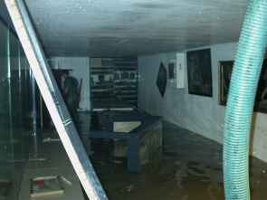
Flood waters in exhibition area

As pointed out above, supply was tricky: all power aggregates were in use, there were only 3 lamps for the whole site, the civil protection agency had run out of personal equipment for their men: some of them did not even have rubber boots, let alone metal-plated ones, they had no personal headlights, and some of them did not wear uniforms. Luckily we were able to have my business-partner as back office: he organized a truck and had the most urgent equipment sent to us from a non-affected area of Switzerland (150 km away).

Once these stumbling blocks were
removed, rescue work was smooth. All objects withstanding rinsing were rinsed, even though the water certainly was not of perfectly clean quality. But the fine mud turns hard like concrete if left to dry on the objects. The rinsed books were packed in plastic bags and sent for freezing to await freeze-drying. The paintings were laid flat on wooden slats to prevent them from warping. The painted sculpture and gilded frames had suffered most: the paint layers themselves – after the several days under water – had turned into sludge. Touching them during rescue always caused loss of the paint at the touched areas; of course these objects were not rinsed. The textiles were all rinsed and could be hung for drying. The cloister has huge attics for drying herbs, which was very convenient.

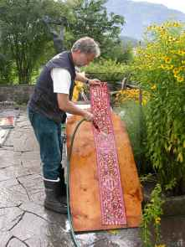
Textile being rinsed free of sludge

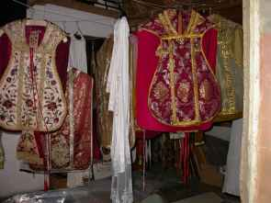
Improvised mechanism in the attic of the monastery for hanging the wet objects to dry

The only textiles suffering extensive loss were 19th c. fabrics and embroideries where the colors were bleeding and often staining other textiles as well. This staining was facilitated by the perforated drawers: when the water was pumped out of the room, suction pulled the (colored) water through drawers beneath. Bleeding textiles were dried between layers of regular household paper (not acid free) trying to prevent further bleeding.

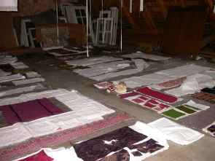
Each possible place is used. Objects with risk of running colors are dried flat

Textiles with cardboard stuffing (bursae, reliquary etc.) were sprayed with ethanol to prevent mold growth and their drying was accelerated using hair dryers set on “cold” and ventilators. We are happy to report, that thanks to fast response, no textiles or books have suffered any mold growth. With the painted objects however, the necessary slow drying (to prevent warping) caused mold outbreak even though the objects were treated with quite strong fungicides.

All in all, the rescue operation was successful. Not having known the collection before proved to be a great advantage and lead to a healthy “coolness” on our side. This might be of importance for future salvage operations: even for places with conservation staff it might be an advantage to have colleagues come in for salvage work.

In spite of the successful outcome, there were, however, details in the organization that will need further attention to improve possible future salvage missions. For example, our business has now bought reflecting vests with our business logo printed on, so we can provide all civilians working with us with some kind of “uniform”. This seems necessary, as – even though the cloister is a “seclusion” and we felt safe from looting – one individual took advantage of the large number of different people who did not know each other and tried to steal silver objects by telling each group that he belonged to the other team! A second outcome is that the importance of disaster preparedness has (fortunately) gained attention. The Swiss Textile Conservators will convene in January for a workshop on personal preparedness (what would each of us do if called in for salvage), and the Swiss Conservation Association will open a work group for disaster response in 2006 to be able to offer services to affected Museums and Institutions. An interesting fact is, that all over Switzerland, the Conservators who were actively involved in salvage work, were conservators working in the private sector. Institutions/Museums were very helpful with staff and material, once contacted, but they were not very proactive.
Some images illustrating the salvage operation in Sarnen can be accessed on our homepage www.prevart.ch/hochwasser ; captions are in German.

Karin von Lerber
Winterthur, Switzerland

CONFERENCE REPORTS

Recovering the Past: the conservation of archaeological and ethnographic textiles

The Fifth Biennial North American Textile Conservation Conference, was held in Mexico City from the 9th to the 12th November 2005. The Theme of the Conference “Recovering the Past: The conservation of archaeological and ethnographic textiles” was reflected in the workshops available and the tours which preceded the conference. Participants had the choice of three workshops; Introduction to Cleaning Systems, Introduction to Natural Dyes, and Roundtable and Workshop: Storage Methodology for Archaeological and Ethnographic Textiles, Introduction to
the Production of Fabrics with Back Strap Loom. The tours took in the rich cultural heritage of Mexico City and its immediate surroundings.

Attending the storage workshop at ENCRyM on Wednesday 9 November proved to be very rewarding. It provided the opportunity to meet conservators from throughout Latin America, North America and Europe. Lead by six instructors, Anne Ennes, Esther Methe, Gwen Spicer, Judith Gomez and Susan Heald, the morning session began with introductions and distribution of extensive bibliographies along with samples of storage materials. Each participant was encouraged to discuss storage problems encountered and solutions they had found.
Issues raised included design of the storage space, tracking of objects using bar codes, storage materials, environmental issues and object mounts. Susan Heald of the National Museum of the American Indian explained the use of barcodes to track objects which had proved very successful for their collection. The pros and cons of various types of card and envelope mounts were discussed, and the consideration of the curator’s requirements for visibility of the object. Questions were raised over Tyvek having an anti-static treatment and whether it should be washed before use. Participants were directed to the Museum of Fine Art website for information on materials: http://www.mfa.org/_cameo/frontend/
Budget, lack of space and materials availability were issues for conservators in Peru who had sourced polypropylene from local factories for the production of archival boxes.

Hidden dangers from previous pest eradication techniques were highlighted in ethnographic and archaeological collections, often unknown if records are non-existent. These residual pesticides which may include arsenic, mercury and DDT, are a danger to the objects and the people who work with them. Highlighting the need for integrated pest management. Anne Ennes of the Textile Museum discussed their pest management policy which includes freezing all new acquisitions, objects that are removed from display before returning to storage, the shop inventory, along with any demonstration materials brought from outside the museum. Sticky traps are also used and all staff, including cleaners and volunteers are made aware of their function.
In the practical afternoon session instructors demonstrated storage solutions they had used for their collections.

Judith Gomez, Museo Nacional de Anthropologia, demonstrated the use of the Ethafoam disc mannequin for display and storage with examples. In addition Judith showed the card window mounts used for the storage of the museum’s extensive collection of Dechado embroideries

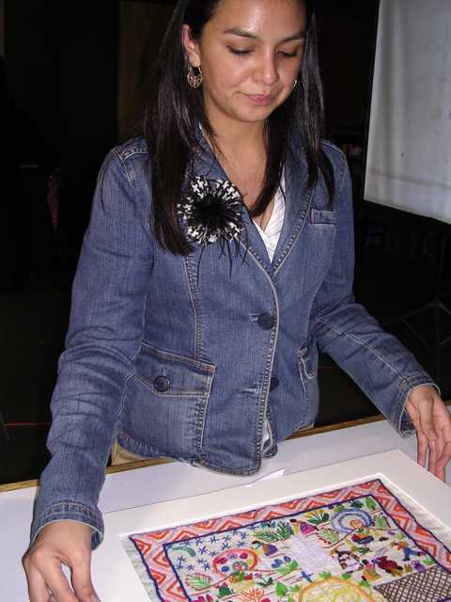
Judith Gomez shows the card window mat storage for Dechado embroideries
Esther Méthé, Textile Museum (Washington), talked through the procedure used by the conservators at the Textile Museum when dealing with a 3 meter long archaeological textile for which a recessed mount was created.

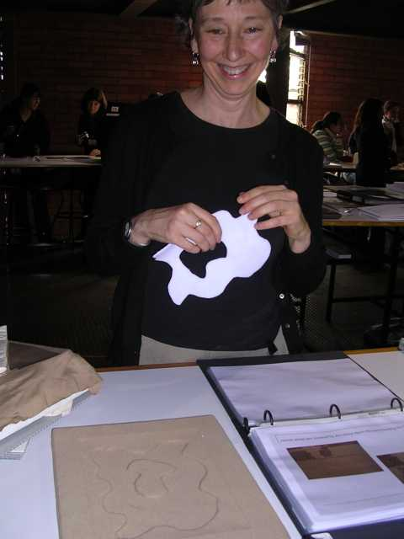
Esther Méthé discusses the procedure for supporting a 3 meter long archaeological textile using a recessed mount

Anne Ennes, Textile Museum, presented a passive mat storage system which included standardised sizes to fit into boxes used by the museum. Gwen Spicer, Spicer Art Conservation, urged conservators to be aware of small museums’ needs which necessitate the best use of resources. Gwen suggested the use of stockingette covered polyester wadding sausages replacing more expensive acid free tissue and further less expensive options.

Susan Heald, National Museum of the American Indian, talked about the storage facility at the Museum which was built in collaboration with Native American Indian Advisors. Rolled and flat storage options were also discussed.
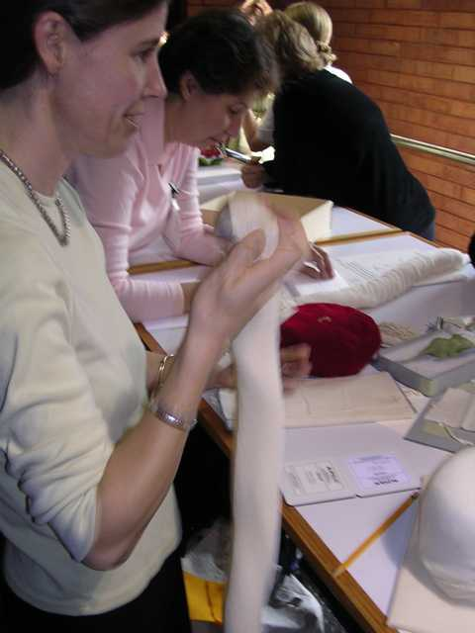
Gwen Spicer demonstrating stockingette covered polyester wadding “sausages”

As always there was too much to cover in the workshop, however each of the participants came away with new ideas.

The evening reception was spectacular. Held at Colegio San Ignacio de Loyola Vizcainas the evening began with registration and welcoming remarks. Keynote speaker Mary Frame, Independent Researcher, gave a fascinating presentation on her research into Peruvian archaeological textiles discussing weaving and production techniques as well as stylistic elements. This was followed by a meal in a candle lit courtyard and Mariachi performers.

Papers in session 1 on the first day of the conference looked at frozen mummified human remains. Fenella France, Vuka Roussakis, Patricia Lissa, Miguuel Xamena, Pedro Santillan, Maria Campero de Larran, Gabriela Dona and Gabriela Ammirati‘s paper ‘Textile Treasures of Llullaillaco’ discussed the discovery and ongoing conservation of Argentina’s three perfectly preserved c.1500 mummies and associated items from an archaeological site 22110 feet above sea level. The project involved the development of a high altitude museum to house the mummies and the testing of the textiles in which the mummies were wrapped to determine condition and effects of long-term low temperatures. Tests showed the textiles to be in remarkably good condition and with care will remain so.

Kjerstin Mackie’s paper ‘Long Ago Person Found – An Ancient Robe Tells a New Story’ reviewed the conservation treatment of the artifacts relating to a young man’s body found in a glacier in British Columbia. Thought to be 550 years old the find included a hat, robe, salmon and a beaver skin pouch. The treatment included analyses to determine the destination of the traveler and whence he came. Pollen samples were collected and showed he was traveling from the coast to the interior. The robe was examined and found to be constructed of 95 ground squirrel pelts embellished with red ochre applied to seams. Robes of ground squirrel are still made today by the first nations people of that region. A fragment of the robe has been displayed under strict environmentally controlled conditions.

Susan Heald, Lauren Chang and Jessica Johnson’s paper ‘Identification and Possible Quantification of Organic pesticides on Ethnographic Textiles During Treatment Phases’ began the second session. This paper linked in well with the discussion regarding residual pesticides from the storage workshop the previous day. It is a wide spread problem that conservators must deal with and may include such organic pesticides as naphthalene, dichlorvos and paradichlorobenzene.

Arabel Pernandez Lopez, Lucianada Silveira and Elizabeth Mendoza’s paper ‘Rediscovering Pre-Columbian Peruvian Textiles: Their Conservation and Documentation at the National Museum, Federal University of Rio de Janeiro, Brazil’ discussed a collection of almost 900 pieces which had been acquired sixty years ago and not touched since. Minimum interventive treatment, surface cleaning, humidification and storage, enabled the safe storage of the objects and thorough documentation.

Soledad Hoces de la Guardia Chellew and Ana-Maria Rojas Zepeda presented ‘An Atacamanian Pre-Columbian Trousseau: Interpretaion of the Tactile and Visual Dialogue in its Textiles’ discussed the unbundling of a funerary bundle discovered in 1975 and unbundled in 1995. The textiles revealed information on yarns, weave structures, finishing and iconography.

During the lunch break tours of ENCRyM’s conservation training facilities were conducted, the delegates meet tutors in their studios and were introduced to the educational programme. Delegate’s posters were displayed for reading at lunch and were available over the two days of the conference.

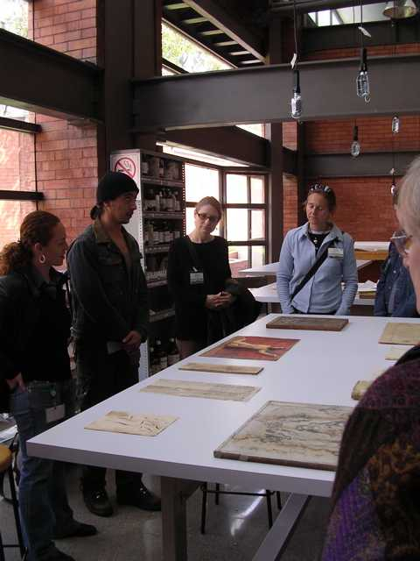
Delegates tour the ENCRyM facilities.
Session three was opened by Sonia O’Connor and Mary Brooks’ paper ‘Looking into the Past: The Potential of X Radiography as an Investigative Technique for Archaeological and Ethnographic Textiles’. This non-destructive technique for examining textiles has proved useful in picking up what the naked eye cannot see. The paper was illustrated by case studies.

Soraya Serra presented ‘Rediscovering Indigenous Basketry from the Caribbean: An Analysis of Impressions on Griddles (burenes) from Vieques, Puerto Rico’. Archaeological evidence of basketry used in the Caribbean is limited to impressions of weaves in clay as the fibre has long since deteriorated. Soraya’s paper discussed the study of these impressions giving rise to the current understanding of the use of basketry.

Beth Szuhay and Jill D’Alessandro presented the paper ‘Darn the Spot! Investigations into Cleaning Raffia Cut Kuba Cloth’. The history and production methods of the cut pile cloths from the Congo region were discussed. Staining of the cloths in the museum’s collection necessitated cleaning prior to exhibition, for which numerous tests were carried out.

Anne Mackay began session four with her paper ‘A Study of Moosehair Embroideed Souvenir Objects’. The history and use of moosehair as an embroidery thread on birch bark boxes was discussed and the conservation treatment of a number of examples illustrated.

Lorena Roman, Abner Gutierrez, Nicolas Gutierrez, Fernando Sanchez Martinez, Fernando Sanchez Guevara and Claudia de la Fuente paper ‘ The Conservation of the Feathers Mosaic:”Cristo Salvador del Mundo” of the National Museum of Viceroyalt, Tepotzotlan, INAH, Mexico’ discussed the conservation treatment of a 16th century Mexican feather art work. Tests on the adhesive used to hold the feathers in position on the 500 years ago mosaic revealed an orchid based adhesive that is still in good condition. Further research on this adhesive is being carried out at ENCRyM.

The final speaker for the day was Lena Bjerregaard with her paper ‘The Leymebamba Textiles’. This presentation discussed the preservation of the mummies found in the northern Peruvian Andes.

Day two of the presentations was hosted by Museo Nacional de Anthropologia. Session five was opened by Christine Guintini and Maya Naunton with their paper ‘Examination and Treatment of a Basketry and Textile Tent Divider from Sudan’. The large heavy work, which was in poor condition, was required for vertical exhibition. Strapping methods for supporting basketry were used, basketry infils and a large purpose built display mount ensured the piece was stable for display.

Stephanie Hornbeck’s paper ‘The Treatment and Preparation for Exhibition of a Composite Material Ceremonial Warrior’s Costume from the Loma People in Liberia’ discussed the treatment of this elaborate costume comprising many different skins, wool, leather and talismans. Many of the elements required consolidation using adhesive techniques for which a variety of adhesives were tested.

First speaker for session six was Priya Ravish with her paper ‘An Invisible Craft’ which discussed the tradition of darning shawls in India. The darning itself is seen as an important ‘living tradition’.

Mercedes Gomez Urquiza’s paper ‘Mexico’s Protection Project of Movable Goods in Religious Buildings: A Textile Study’ looked at the historical and legal constraints when dealing with cultural heritage within the Church. Theft of artifacts has highlighted the importance for detailed documentation of collections that are the property of the State but house and cared for by the Churches.

Judith Gomez Gonzalez and Alejandro Gonzalez Villarruel’s paper ‘To Repair or to Conserve the Ethnographic: The Ethnographic Displays at the Anthropology Museum in Mexico’ gave case histories of the conservation treatment of a number of textiles currently on display in the Museum.

A lunch-time tour of a textile specific exhibition at the MNA was conducted, with fascinating examples of indigenous textiles.

Session seven was begun by Candida Fernandez de Calderon with the paper ‘Mayan Textiles Centre of San Cristobal de las Casas, Chiapas, Mexico: A Commitment to the Conservation and Diffusion of Textile Art’. This paper discussed the importance of Mayan weaving and the establishment of a Trust that has set up a Textile Museum to house Mayan pieces. In addition the conservation treatment of the pieces was illustrated.

Tatiana Kousoulou’s paper ‘First Aid and Preventive Conservation for Ecclesiastical Vestments in the Greek Orthodox Church’ discussed her work with the Church collections. The collections are housed in remote (and spectacular) locations where the conservation was to be carried out in situ alongside the Priests.

Lana Panko, Alejandro Ruiz and Zoila Ramirez Sales’ paper ‘Negotiating Meaning and Cultural Memory with Maya Textiles’ discussed the sacred meaning of the textiles and the importance of maintaining a partnership with the community. The spiritual energy of the objects was highlighted – objects should not be boxed - and taken into account when designing displays where textiles were on open display on forms that fitted the community’s needs by using all natural materials.

DY Begay and Jeanne Brako presented the paper ‘Using Collections to Bridge Communities’. The authors emphasized the importance of involving communities in the museum, creating partnerships. Strategies to encourage indigenous participation in museums have been set up and include scholarships to attend Museum Studies courses, internship programmes and workshops.

The final session of the conference was opened by Patricia Lissa, Silvana Di Lorenzo and Pia Villalonga’s paper ‘The Conservation Treatment of Bolivian “Traje de Danzante” of the Ethnographic Museum of Buenos Aires’. The conservation treatment involved a multi-discipline approach due to the variety of materials involved, including a wooden frame, wool and cotton fabrics and elaborate silver work.
The day was concluded by two lectures dedicated to Irmgard W Johnson Ethnologist at the MNA. Felipe Solis, Director, MNA recollected his memories of working with Mrs Johnson in his presentation entitled ‘Tribute to Irmgard W. Johnson’. Virginia Davis recounted Mrs. Johnson’s long career in her paper ‘Irmgard W. Johnson: Outstanding Textile Researcher of Textiles’. Mrs. Johnson’s dedication to collecting a recording the textile traditions of the indigenous people of Mexico has been an invaluable asset to the MNA, Mexico and internationally.

A short presentation followed aimed at encouraging delegates to attend the 2007 NATCC in Washington DC.

The finale of the conference was a tour of Teotihuacan on the following day. The tour was guided by a local archaeologist and included a climb up the tallest pyramid and a spectacular lunch at La Gruta, Restaurante, located in a candle lit cave, where traditional dishes were served.

Mexico City was a vibrant and exciting location for the Conference. The seamless
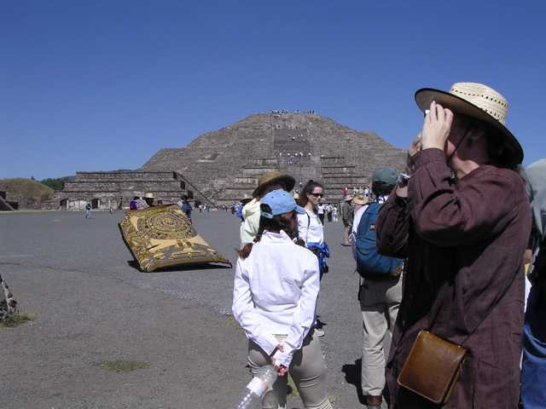
Delegates tour Teotihuacan

translators must be congratulated for a marvelous job. Papers covered the conference theme and the inclusion of indigenous peoples was an important aspect. The hosts have set a high standard and I am looking forward to Washington 2007 with enthusiasm.

Enquiries regarding the conference Pre-prints should be directed to Suzanne Thomassen Krauss thomassenkrauss@si.edu.

I wish to thank the board of the NATCC for the fees waiver which assisted me to attend the Conference.

Tracey Wedge
Textile Conservator
Auckland, New Zealand

(See the ICOM Ethnographic Working Group Newsletter for additional NATCC workshop reviews by Kjerstin Mackie)

“The Preservation of Religious Textiles”

On September 10th 2005 the Netherlands Textile Committee (TC) organized in The Hague an international symposium that focused on the preservation of religious textiles, which are often still in use. It turned out as a very interesting conference and we are happy we got many positive reactions.
After Drs. Judith M. Tegelaers (Chair of the Netherlands Textile Committee) welcomed the participants, chairperson of the day Dr. E. Janssen (Collections manager of Museums, Conservation Libraries and Heritage of the City of Antwerp, Belgium) gave an introduction.

During the last fifty years the secularization in the Western world and in other regions has lead to changes in the preservation of religious textiles. Part of this heritage is unfortunately lost forever. Other pieces are preserved by transferring them to a museum collection. On the cutting edge are those textiles that travel between church and museum gallery. The day was dedicated to discuss the area of tension, or maybe even the conflict, between the use of the textiles and their preservation. Many countries have to deal with these issues. Not only textiles from Western-European Christian tradition but also textiles from Eastern Orthodox churches, Judaism, Buddhism, and other religions were discussed.

First G. van den Hout (director Museum Catharijneconvent Utrecht, the Netherlands) gave an In memoriam for Dr. Tuuk Stam, who has been curator of textiles at the Museum Catharijneconvent in Utrecht and who has passed away in 2003. She was one of the initiators of this textile symposium.

The first lecture by R. Lugtigheid (Conservator, Stichting Kerkelijk Kunstbezit in Nederland -SKKN-, the Netherlands) was about Religious textiles, a special but vulnerable heritage. Report on research project into the state of preservation of textiles in the Dutch churches. It turned out that since the Vaticanum II the preservation of a lot of textiles is a big problem and needs urgent attention.

M. van Roon (Researcher and curator of the Museum of the Amsterdam University, the Netherlands) spoke about Recycling textiles in the Catholic Church of the 19th century; changing values and functions. She pointed out a lot of medieval textiles were damaged due to the recycling, but at the same time it also meant they were not completely lost.

In Saving by using, to preserve the cultural heritage of churches by making use of it A. Klint and M. Bergstrand (Textile Conservators, The National Heritage Board of Sweden) explained the role of the National Heritage Board in stimulating churches in taking measures for preventive conservation. This is done by giving courses with active participation of the churches.

E. Alexandri,T. Koussoulou and S. Rapti (Textile conservators and teachers at the Technological Education Institute of Athens, Department of Conservation of Antiquities and Works of Art, Department of Conservation of Antiquities and Works of Art, Greece) spoke about The Epitaphs in the Greek Orthodox Church: preservation proposals when they are still in use. The draped epitaphs, which are often hundreds of years old, need special care while in use and they also need special conservation treatment

At the end of the morning session eight people gave a short introduction to the posters they presented. In the poster session more attention was given to conservation projects of (individual) textiles. During lunch there was time to read the posters and to talk to the authors.

The afternoon started with the lecture of M. Vroon (Textile conservator, Dom Aachen, Germany) Synchronized efforts. Report on the inventorisation project of ecclesiastical textiles, about the necessity and the advantages of a uniform inventory of ecclesiastical vestments. She showed the public interesting examples.

In The Preservation of Religious Textiles from the Himalaya T. Heady (Senior object conservator, St. Pauls Cathedral, London) told us about the course in Tangka-conservation she gave in Kathmandu. She stressed how important it is to use local knowledge and materials if one teaches in a non-museum situation.

The lecture of J.M. Cohen (Curator, Jewish Historical Museum Amsterdam, the Netherlands) Changing values of Jewish Textiles was about the use and reuse of Dutch Jewish ceremonial textiles from a historic point of view, in relation to the specific social impact today within the Jewish community in Amsterdam.

M. Kite (Senior textile conservator, Victoria and Albert Museum, London, UK), the last speaker of the day, gave an interesting paper about The preservation of religious textiles in museum context. She told us how in the past these textiles were put on display without any explanation and how today they are presented with attention to their context, function and iconography.

After the lectures there was a lively forum session with all the speakers. The day was closed with an informal reception.

The presentations of this symposium will be published in post-prints, as part of the Textile committee’s annual reports. In the summer of 2006, this publication will become available. All participants of the symposium will get a copy. For more information, please visit our website www.textielcommissie.nl.

Dr. Elsje Janssen
Assistant co-ordinator Textile Workgroup,

Collections manager of Museums, Conservation Libraries and Heritage
City of Antwerp, Belgium

CALENDAR OF MEETINGS & COURSES

“Textile Conservation in Brazil: museums and Collections”

Date: 8 to 13 May 2006
Location: Museu Paulista da Universidade de Saõ Paulo
Registration deadline: 15 December 2005
Fees: R$ 200,00 (two hundred reais) before 15 December 2005
R$ 300,00 (three hundred reais) until 20 April 2006
The number of participants is limited to 200. Since a large number is expected, the following criteria will be used for pre-registration: 100 for museum professionals, conservators, graduate and post-graduate students from conservation and museum studies courses; 50 for graduate and post-graduate fashion courses; 50 for general public.

Languages: Portuguese and English
Program and further details: www.tecidosnobrasil.org.br

“Colour & Time
Colour in Conservation and Restoration”
12th SFICC Study Days

Date: 21-23 June 2006
Location: Institut national du patrimoine, Paris, France
Description: Colour is a fundamental element in our perception of the world around us, most particularly in the cultural and artistic domains. Each intervention concerning the conservation or restoration of cultural heritage, regardless of the nature, will most probably have an influence on the colour of the object, its perception, its support, its context. For this reason it seemed to us interesting to organise a congress on the theme of colour and conservation-restoration: How are the colours of cultural objects formed? How have their colours evolved? Can we reproduce them? How should we measure, identify and reproduce their colours? What type of lighting should one use in their conservation studio? These are some of many examples that we hope will be treated in this congress.
You will find below a list of some of the themes that we have classified in a non-definitive order. They can treat historical, scientific or technical aspects, or concern a specific treatment report. In any event they should approach the problem of colour and conservation. We hope to have proposals from professionals working with all types of cultural heritage in its largest sense, as indicated by the opening paragraph or by the themes listed below.
Interdisciplinary communications (Historians, scientists and restorers) are most welcomed.
As usual, papers shall have interdisciplinary content, regarding to scientists, art historian and conservators approach.
Themes
- Introduction and basic questions: characterisation and perception, definitions of colours, characterisation, scientific measurements, colorimetric measurements, colour codes and charts
- Colour in works of art: the colour of the natural constituents of artworks, history and practice, pigments and mediums, the fabrication of pigments, laboratory analyses, characteristics, aging of pigment, in-painting, reversibility, the question of patinas
- Principal domains concerned: painting (easel, wall, drawings, miniatures etc), metal, textiles, ceramics, enamels; architecture: painted facades, replacing old colours, polychromic studies of architectural sites (portals, monumental sculpture etc.
- Subjects not treated: the psychology of colours, heraldic…..
The congress will be accompanied by a "Colour Salon" where divers professionals can present their material or documentation in relation with the congress: scientific or historical literature, pigments and restoration products, colour codes or charts, colour measuring devices, lighting systems etc.
Registration deadline: 31 March 2006
Fees: 130 € for SFIIC members
170 € for non members
50 € for students
35 € extra after 31 March 2006
Call for papers: 30 September 2005
Deadline for final papers: 31 January 2006
Poster submissions:
Languages: French and English with simultaneous translation
Program and further details: www.sfiic.asso.fr

“Textiles and Text: Re-Establishing the Links Between Archival and Object-Based Research”
Third Annual Conference of the Arts & Humanities Research Council Research Centre for Textile Conservation and Textile Studies Textile Conservation Centre, University of Southampton
Date: July 11-13, 2006
Location: Winchester School of Art, University of Southampton, Winchester, UK
Description:
Third Annual Conference of the Arts & Humanities Research Council Research Centre for Textile Conservation and Textile Studies Textile Conservation Centre, University of Southampton
The primary focus of this conference is the interrelationship between archival and bibliographic research and the study of extant objects. Sessions will consider how archival and bibliographic research can inform our knowledge of textiles and dress, in terms of their production, consumption, dissemination and deterioration and how the study of extant objects can give added depth to this analysis. Sessions will also be devoted to considering: what tools, including oral history, can be used to investigate textiles produced by cultures that are not predominantly text based and how scientific and photographic analytical techniques can provide clues which cannot readily be gleaned either from the objects or written sources.
Call for papers: Papers are encouraged that cover a wide geographical remit so allowing comparison between ‘Eastern’ and ‘Western’ traditions. Papers relating to the four Research Centre themes set out below are welcomed. A broad chronological span is also sought to encompass issues ranging from pre-history to the present day.
Papers are welcomed that address the range of topics listed above. Papers will be 20 minutes long and there will be time for questions. Please submit your abstract by 31 January 2006 either as hard copy to Christine Bennett, Textile Conservation Centre, University of Southampton, Park Avenue, Winchester, Hampshire, SO23 8DL or by email to C.G.Bennett@soton.ac.uk. The papers will be selected through a peer review process and successful speakers will be notified by the end of February 2006. After the conference, the papers will be published as a volume of conference proceedings to be edited by Maria Hayward and Elizabeth Kramer. All speakers will be required to submit a full version of their paper, ready for publication, at the conference.
Fee and deadline for registration: The conference fee will be in the region of £100 and the deadline for bookings is 1st June 2006. A booking form will be available in due course as a pdf document from the conference website www.soton.ac.uk/~contex
Background
The AHRC Research Centre for Textile Conservation and Textile Studies was established as a result of a five year award of £984,000 for 1 July 2002-30 June 2007.
The overall aim of the Research Centre is to improve the care and interpretation of textiles by enhancing knowledge and understanding of textiles and textile conservation. The Research Centre is based at the Textile Conservation Centre, University of Southampton and it is a partnership between the Universities of Southampton, Bradford and Manchester.
The Research Centre has four themes:
• Textile Materials - focusing on the material
properties of textiles and their degradation
• Textiles & Text - focusing on links between
surviving artefacts and archival records
• Modern Materials focusing on modern textiles
including man-made, regenerated and synthetic fibres as well as man-made materials found in association with textiles and dress
• Worldly Goods - focusing on textiles in domestic
contexts, ranging from tapestries in historic houses to garments deliberately concealed within buildings.

Contact Info:
Christine Bennett
C.G.Bennett@soton.ac.uk

NOTICES

Issues in the Conservation of Textiles

Commissioned editors: Mary M Brooks & Dinah Eastop
Research Assistant: Joelle Wickens

Issues in the Conservation of Textiles is a forthcoming volume in the ‘Readings in the Conservation’ series which is published by the Getty Conservation Institute (GCI).
As the editors, we want this book of collected articles and essays to

~ reflect the history and development of textile conservation
~ illuminate current theory and practice
~ identify future challenges
~ suggest ways forward
~ be truly international

We welcome suggestions from textile conservators, scientists and teachers as to which articles should be included. Please contact us at the address below with your ideas and suggestions. We are interested to know which three published articles, books or book chapters you have found most useful in developing your approach to textile conservation and which you believe have been landmark papers in the development of discipline and the profession. Please do suggest publications in a range of languages as the Getty have generously offered to cover translation costs. Our aim is ensure this book truly reflects the development of textile conservation as well as looking towards future challenges and developments. All those suggesting ideas will be listed in the resulting volume which we hope will be published within the next two to three years.

Contact details:
Please send details of the publication(s) by post or email to Joelle Wickens, ideally including the author’s names (s), date of publication, the title and the publisher together with your name, address and e-mail address.

Postal address:
Textile Conservation Centre,
University of Southampton
Park Avenue
Winchester
Hampshire SO23 8DL
United Kingdom

E-mail address: Joelle.Wickens@soton.ac.uk

Thank you for your interest and support: we look forward to hearing from you!

Dinah Eastop and Mary Brooks
Senior Lecturers, Textile Conservation Centre, University of Southampton

Metal Threads - Call for volunteer

Do you have expertise in the composition, manufacture and conservation of metal threads? Are you interested in working with experts in metal conservation to see how textiles comprising metal threads can be treated? The Textiles Working Group and the Metals Working Group would like to
establish a liaison between the two groups to address the problems of textiles decorated with metal threads. We need a volunteer from each working group to coordinate such activity. If you are interested in participating in this effort, please contact Mary Ballard, Textile
Working Group Co-ordinator, at ballardm@si.edu.

Developments in Textile Conservation at the University of Alberta, Canada

Retirements and new staff have changed the face of textile conservation in the Department of Human Ecology at the University of Alberta in Edmonton, Canada. Here is a quick update.
Dr. Elizabeth Richards, professor in textile science and 2000, was head of textile conservation for a year at the Malta Centre for Restoration and then returned to Canada. She returned to the University of Alberta to teach preventive conservation in the fall of 2003 and to oversee the post-flood recovery of items from our clothing and textile collection in the winter and spring of 2004. Conservators Elizabeth Griffin, Linda-Sue Burwood, Carolyn Poon assisted in this important project along with Merrilee Vouk, Marcia McLean, Lucie Heins, and Vlada Blinova. Elizabeth is doing private conservation in the fall and then takes retirement seriously and spends time quilting, sailing and skiing.

Shirley Ellis left the University of Alberta in the fall of 2003 after eight years of service to the Clothing and Textiles Collection, the Textile Conservation Service (a treatment service for outside clientele discontinued in 2001) and as course instructor in preventive and textile conservation. She left the University to take up duties as textile conservator at the Royal Ontario Museum in Toronto, Canada and has been busy since then preparing artifacts for new galleries and exhibits there.

Dr. Nancy Kerr officially retired as Professor in textile conservation and textile science in December 2003. She remains active in the Department of Human Ecology, teaching the textile conservation treatment course in spring 2004 (assisted by Elizabeth Griffin) as well as undergraduate textile science courses and graduate clothing and textiles courses.

Dr. Irene Karsten, a graduate in textile conservation of the University of Alberta, returned in December 2004 to take up the cross-appointed position of museum conservator in the Departments of Human Ecology and Museums and Collections Services. In Human Ecology, she effectively replaces Shirley Ellis as conservator for the Clothing and Textiles Collection and takes on full responsibility for the preventive and textile treatment conservation courses. Occasionally she also teaches graduate seminars with a conservation theme, such as one focused on the effects of moisture and pH on textile properties and degradation this fall. At Museums and Collections Services, Irene is responsible for diverse collections, mostly in the natural sciences, but also of art, ethnographic and historic objects, and primarily from a preventive conservation perspective. Current projects include the design for proper storage of a valuable collection of East Asian textiles recently donated to the University.

The Eu-ARTECH Project

“Eu-ARTECH” stands for Access, Research, and Technology for the conservation of European Cultural Heritage. To quote its brochure: “The purpose of Eu-ARTECH is to establish a lasting interoperability among the participating institutions, to promote cooperation and exchange of knowledge among leading centres in the field, with a view to build a common European research area.”

Currently a survey has been launched to gather information on methods and materials used in the cleaning of stone and metal artefacts and paintings, the consolidation of stone and mural paintings, and to treat agents of biodeterioration on stone, paintings, and mural paintings.

European textile conservators are urged to investigate the possibility of initiating similar surveys and studies in areas of textile conservation. For more information contact Eu-ARTECH
Fax: 0039.055.5225483
Email: euartech_cnr@yahoo.com
Website: www.eu-artech.org

Please report back to this working group about your activities.
Textiles Off-campus Programs (TOP)

It has been several years since information about the textile science courses available by long distance from North Carolina Sate University, College of Textiles has appeared in this newsletter. The acronym TOP stands for “Textiles Off-campus Program”.

To quote the program’s website, “TOP is designed to deliver continuing education courses to the student by a variety of mediums including CD-ROM’s, VHS Tapes, and Online Delivery. Recent textile BS graduates can continue their education through the TOP Master of Science and Master of Textiles degree. The stay-at-home parent can take courses to rejoin the workforce or start a home business. Textile employees, from top management to the production floor employee with busy schedules, can continue their education to enhance their careers. The wide varieties of delivery methods allow the student flexibility of viewing courses in the office, on the production floor, at home or on the road.”

Classes, which are recorded in an on-campus classroom setting, are taken for credit or audit. A Bachelor of Science degree is not available through TOP but a master’s degree can be obtained without a residency requirement.

The College of Textiles at NC State also offers a certificate program for those desiring to increase their knowledge of textiles through a structured study program. A certificate signed by the Associate Dean for Academic Programs will be awarded upon satisfactory completion of an approved interrelated 15 (minimum) semester hours. Certificates are awarded in the following areas:
Advanced Polymer & Color Chemistry
Apparel Production
Dyeing and Finishing
Fabric Manufacturing
Textile Administration
Textile Fundamentals
Yarn Manufacturing

Applicants must possess a bachelor’s degree from an accredited institution. To be considered for the program, an original transcript must be submitted with your application. After acceptance into the program your advisor will assist you in selecting courses each semester from those listed.

For course listings and more information visit the NCSU TOP website: http://www.tx.ncsu.edu/academic/distance/

BOOKS

ICOM 14th Triennial Meeting, The Hague Preprints.
Ed. Isabelle Verger

ISBN 1-84407-253-3, softcover, 2 volumes, 1091 pages, numerous illustrations.

Contents – Documentation, Education and training, Ethnographic Collections, Glass and ceramics, Graphic documents, Leather and related materials, Legal issues in conservation, Metals, Modern materials and contemporary art, Mural paintings, mosaics and rock art, Natural history collections, Paintings, Photographic records, Preventive conservation, Scientific research, Sculpture and polychromy, Stone, Textiles, Theory and history of conservation-restoration, Wet organic archaeological materials, Wood, furniture and lacquer.

The Textile chapter includes 12 papers and 4 posters.

Available from:

James & James / Earthscan
8-12 Camden High Street, London, NW1 0JH, UK.
Tel: +44 (0) 20 7387 8558.
Fax: +44 (0) 20 7387 8998
Email: earthinfo@earthscan.co.uk

ICOM-CC Secretariat
Isabelle Verger
c/o ICCROM
13, via San Michele
00153 Rome, Itlay
Tel: +39 06 58 55 34 10
Fax: +39 06 58 55 33 49
Email: secretariat@icom-cc.org

Unravelling Textiles: a handbook for the preservation of textile collections
Foekje Boersma et al.

ISBN 1873132646, hardback, 170 pages, 78 illustrations

Unravelling Textiles: a handbook for the preservation of textile collections is an initiative of the Netherlands Textile Committee which has played an active role in the preservation of textiles in both museum and private collections and encouraging the gathering and exchange of information and knowledge about textiles.

This book, previously published in Dutch in 2000, sets out to present the basic information for the professional safekeeping of textile collections. Aimed at curators and owners of textile collections, collection management staff, conservators and students, much of the experience recorded has been drawn from Northern Europe but the general thrust of the book has global relevance.

Contents - Chapter 1: Materials- properties of fibres, Chapter 2: Degradation of textiles, Chapter 3: Atmosphere, Chapter 4: Light, Chapter 5: Insects and fungi in textile collections, Chapter 6: Storage, Chapter 7: Transportation, Chapter 8: Exhibition, Chapter 9: Conservation Materials, Chapter 10: Conservation and restoration, Chapter 12: Collection management.

Available from the following:

Archetype Publications,
6 Fitzroy Square, London, W1T 5HJ
Tel: 0207 380 0800
Fax: 0207 380 0500
Email: info@archetype.co.uk

JG Publishing Services
655 West 80th Place
Los Angeles, CA 90045-1404
USA
Tel: +1 88 502 8600
Email: info@jgpubs.com

OBITUARY: KATHRYN O. SCOTT

Kathryn Olivia Scott died peacefully in her home in the Murray Hill section of New York on Saturday, October 215, 2005. She was 95 years old. Born in Galesburg, Illinois, Miss Scott moved to Manhattan in the early 1930s. After holding a variety of jobs and attending courses at the Arts Students League, she was given a carton of textiles by a dealer and collector of pre-Columbian art: he asked her to treat them, he didn’t know anyone else with her ingenuity. Thus began her career in textile conservation. Her trademarks were to plan carefully and to seek the advice of leading experts in whatever field she had a question: it might be the renowned Dr. Junius Bird or a superb surfactant chemist, but she would carefully find the best answer to what she needed to know. She went on to work on many fine textiles for a number of private and museums in New York City and around the United States. Beginning in 1964, she was an Adjunct Associate Professor of Conservation at the Conservation Center, Institute of Fine Arts, New York University, where she trained many American textile conservators in practice today. She leaves behind a niece and a nephew as well as many, many friends and admirers, all devoted to her. Burial is private; a memorial celebration is planned in the next few weeks.

Mary Ballard and Rebecca Rushfield.

SUBMISSIONS

The Newsletter needs your contributions. We would like to have summaries of interesting projects, ongoing problems, and upcoming studies in your area, city, region, or nation. Notices of exhibitions and books are also welcome. This is an opportunity to report in a few paragraphs on a major development to colleagues around the world. Please send your submissions to any of the following:

Mary Ballard, Co-ordinator
Senior Textile Conservator
Smithsonian Center for Materials Research & Education
Museum Support Center
4210 Silver Hill Road
Suitland, Maryland
USA 20746
Tel: 301 238-3700 ext. 145
Fax: 301 238-3709
Email: ballardm@si.edu.

Pia Christensson, co-editor
Textile Conservator
Kulturmagasinet
Helsingborgs Museer
Gisela Trapps väg 1
S-254 37 Helsingborg
Sweden
Tel: +46 42 10 45 19
Fax: +46 42 10 45 10
Email: pia.christensson@helsingborg.se

Jan Vuori, co-editor
Textile Conservator
Canadian Conservation Institute
1030 Innes Road
Ottawa, Ontario
Canada K1A 0M5
Tel: 613 998-3721
Fax: 613 998-4721
Email: jan_vuori@pch.gc.ca

Tracey Wedge, co-editor
Textile Conservator
2 Ward Terrace
Sandringham
Auckland 1003
New Zealand
Tel: +64 9 846 2412
Email: textileconservator@paradise.net.nz

