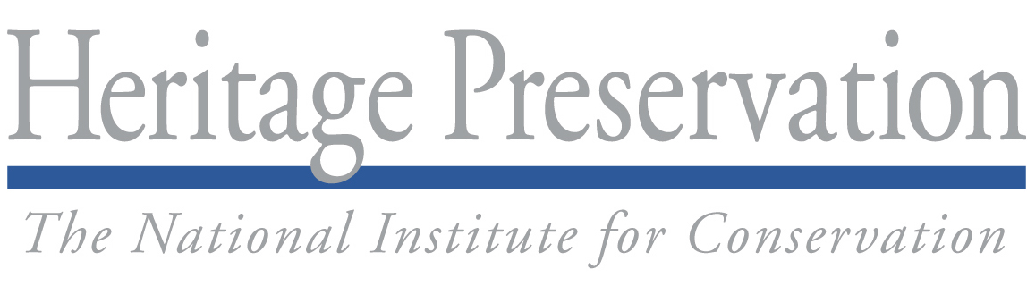

For Immediate Release Contact: Mary Rogers, 202-233-0800 or taskforce@heritagepreservation.org

What Will You Do for MayDay?

Cultural institutions prepare for emergencies

WASHINGTON, DC—Libraries, museums, archives, and arts and historic preservation organizations across the nation will set aside May 1, 2010, to participate in MayDay, a national effort to prepare for disasters.
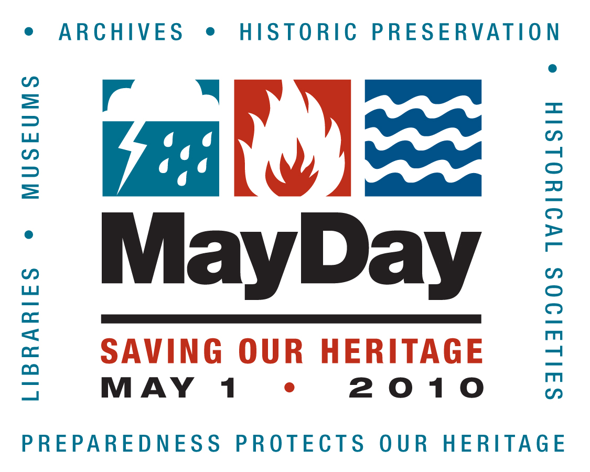
Sponsored by Heritage Preservation and other members of the Heritage Emergency National Task Force, MayDay encourages organizations to take one simple step to protect the art, artifacts, records, and historic sites they hold in trust.
Any organization can participate in MayDay. Last year, staff at the Pennsylvania College of Technology’s Roger and Peggy Madigan Library in Williamsport, PA, tagged priority collections with glow-in-the-dark stickers. Staff at the Sam Rayburn House Museum in Bonham, TX, received fire safety and extinguisher training from the Bonham Fire Department. The Balboa Art Conservation Center in San Diego, CA, updated five “Guides to Emergency Preparedness Resources” for states in the West, and made them available as free resources on its Web site.
Heritage Preservation is collecting examples of creative but practical measures like these to share online. Any institution submitting a brief description of 2010 MayDay plans or accomplishments by May 21, 2010, will be entered in a drawing for disaster supplies donated by Gaylord Brothers.
Heritage Preservation will also offer its award-winning Field Guide to Emergency Response and Emergency Response and Salvage Wheel at special MayDay prices from April 14 through May 31.
Visit www.heritagepreservation.org/programs/tflessons/MayDay.html for project ideas, information on prizes and the publications sale, and customized versions of the MayDay logo for publicizing this national event.

Heritage Preservation’s MayDay 2010 campaign is supported by BELFOR Property Restoration.
_______________
The Society of American Archivists (SAA) created the MayDay initiative in 2006 and promoted the idea to its members and allied organizations. The following year, the Heritage Emergency National Task Force and SAA expanded the concept to include all kinds of collecting institutions and historic preservation interests. www.archivists.org.
The Heritage Emergency National Task Force is making disaster preparedness and response a higher priority for cultural heritage organizations across the country. The Task Force—an initiative of Heritage Preservation and the Federal Emergency Management Agency—is a partnership of 41 national service organizations and government agencies. www.heritageemergency.org.
Heritage Preservation is a national non-profit organization dedicated to preserving the cultural heritage of the United States. By identifying risks, developing innovative programs, and providing broad public access to expert advice, Heritage Preservation assists museums, libraries, archives, historic preservation and other organizations, as well as individuals, in caring for our endangered heritage. www.heritagepreservation.org.

###

